**GATE MANAGEMENT SYSTEM**

**Submitted By : Bhuvan Gupta(2020b4A71654P)**

**Akshaj Dixit(2020B4A70948P)**

**Video link :**

**https://drive.google.com/drive/folders/1tI84mOJTK1W5jW2_4x74MLdSXRBDy1IM?usp=sharing**

# ENTITY RELATIONSHIP MODEL

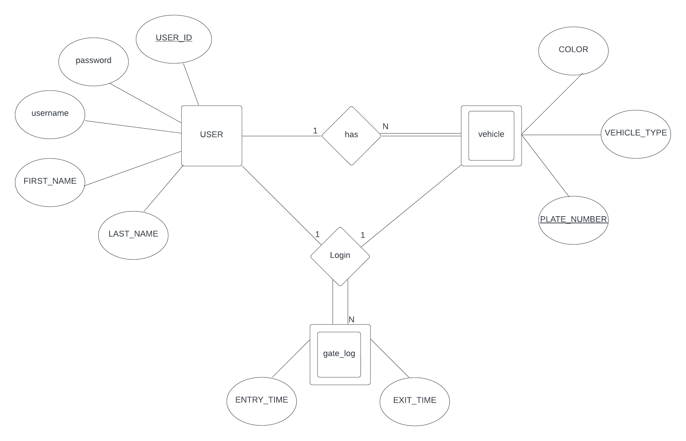

# 

# 

# Converting ER diagram to Relational

user (USER_ID, FIRST_NAME, LAST_NAME, username,password)

PK: USER_ID

vehicle(USER_ID,PLATE_NUMBER,COLOR,VEHICLE_TYPE)

PK:(USER_ID,PLATE_NUMBER)

FK: USER_ID REFERENCES user(USER_ID)

gate_log(USER_ID,PLATE_NUMBER,ENTRY_TIME,EXIT_TIME)

PK:(USER_ID,PLATE_NUMBER,ENTRY_TIME)

FK: USER_ID REFERENCES user(USER_ID)

PLATE_NUMBER REFERENCES vehicle( PLATE_NUMBER)

# Converting it to 3rd Normal Form

1.user table

Functional Dependencies

1. USER_ID -> FIRST_NAME
2. USER_ID -> LAST_NAME
3. USER_ID -> username
4. USER_ID -> password

1NF

Table has no multivalued attribute therefore it is in 1st NF

2NF

USER_ID is **Candidate Key** in above table and all other attributes fully functional dependent on USER_ID therefore it is in 2NF

3NF

There is no Transitive relationship in the table therefore it is in 3NF.

2. Vehicle table

Functional Dependencies

a)PLATE_NUMBER -> COLOR

b)PLATE_NUMBER -> VEHICLE_TYPE

1NF

Table has no multivalued attribute therefore it is in 1st NF

2NF

Candidate Key for the table is (USER_ID,PLATE_NUMBER) but COLOR and VEHICLE_TYPE are partially dependent on the Candidate Key therefore **not in 2NF**

We divide the relation into two relations

i).vehicle(PLATE_NUMBER,COLOR,VEHICLE_TYPE)

PK: PLATE_NUMBER

Functional Dependencies

a)PLATE_NUMBER -> COLOR

b)PLATE_NUMBER -> VEHICLE_TYPE

Now it is in 2NF as COLOR and VEHICLE_TYPE are fully dependent on PLATE_NUMBER which is the Candidate Key

ii).owner(PLATE_NUMBER,USER_ID)

PK: (PLATE_NUMBER,USER_ID)

FK: USER_ID REFERENCES user(USER_ID)

PLATE_NUMBER REFERENCES vehicle( PLATE_NUMBER)

As there is no functional dependency in this relation therefore table is in 2NF

3NF

For vehicle table we do not have any transitive dependencies therefore it is in 3NF

For owner table we do not have any functional dependencies therefore by default it is in 3NF

3.gate_log table

Functional Dependencies

ENTRY_TIME,USER_ID,PLATE_NUMBER->EXIT_TIME

1NF

Table has no multivalued attribute therefore it is in 1st NF

2NF

The Candidate Key is a combination of ENTRY_TIME,PLATE_NUMBER,USER_ID which shows that the non prime attribute of EXIT_TIME has full dependency. Hence it is in 2NF

3NF

There is no Transitive relationship in the table therefore it is in 3NF.

# Final Relational Table

**1.user (USER_ID, FIRST_NAME, LAST_NAME, username,password)**

**2.vehicle(PLATE_NUMBER,COLOR,VEHICLE_TYPE)**

**3.owner(PLATE_NUMBER,USER_ID**

**4.gate_log(USER_ID,PLATE_NUMBER,ENTRY_TIME,EXIT_TIME)**

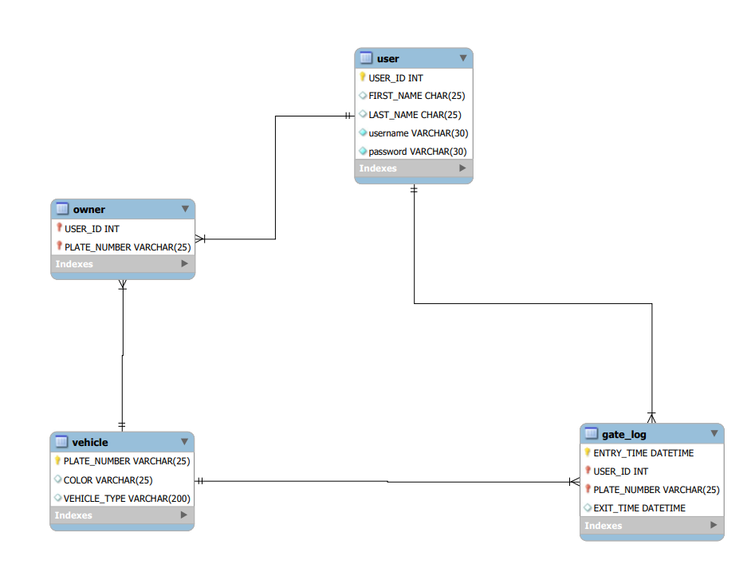

Fig 1: RELATIONAL MODE

# SQL Querries

## 1.DDL Querries

create Database gate_management;

use gate_management;

create table user(

USER_ID INT NOT NULL PRIMARY KEY AUTO_INCREMENT,

FIRST_NAME CHAR(25),

LAST_NAME CHAR(25),

username varchar(30) unique not null ,

password varchar(30) not null

);

CREATE TABLE vehicle(

PLATE_NUMBER varchar(25) not null,

COLOR varchar(25),

VEHICLE_TYPE varchar(200),

PRIMARY KEY(PLATE_NUMBER)

);

CREATE TABLE owner(

USER_ID int not null references user on delete cascade on update cascade,

PLATE_NUMBER varchar(25) not null,

PRIMARY KEY(USER_ID,PLATE_NUMBER),

FOREIGN KEY (USER_ID) REFERENCES user(USER_ID) ON DELETE CASCADE ON UPDATE CASCADE,

FOREIGN KEY (PLATE_NUMBER) REFERENCES vehicle(PLATE_NUMBER) ON DELETE CASCADE ON UPDATE CASCADE

);

CREATE TABLE gate_log(

ENTRY_TIME datetime default current_timestamp,

USER_ID int not null ,

PLATE_NUMBER varchar(25) ,

EXIT_TIME datetime default NULL,

PRIMARY KEY(ENTRY_TIME,USER_ID,PLATE_NUMBER),

FOREIGN KEY (PLATE_NUMBER) REFERENCES vehicle(PLATE_NUMBER ) ON UPDATE CASCADE,

FOREIGN KEY (USER_ID) REFERENCES user(USER_ID ) ON UPDATE CASCADE

);

## 2. Inserting records into the table

INSERT INTO user (FIRST_NAME,LAST_NAME,username,password) VALUES

('Amit','Kumar','hello','amitkumar'),

('Sumit','Wilson','heilo','sumitwilson'),

('Rajesh','Kumar','mathematicalmethods','rajeshkumar'),

('Trilok','Mathur','Topo','trilokmathur'),

('Krishan','Kumar','graphs','krishankumar'),

('Balram','Dubey','Funal','balramdubey'),

('Devendra','Kumar','pde','devendrakumar'),

('Sangeeta','Yadav','diffgeo','sangeetayadav'),

('Ankit','Sharma','arrays','ankitsharma'),

('Amita','Kumari','hell','amitakumari');

INSERT INTO vehicle (PLATE_NUMBER,COLOR,VEHICLE_TYPE) VALUES

('RJ15FD9951','black','Two-wheeler'),

('RJ65FD9051','red','Four-wheeler'),

('RJ61YD3251','blue','Two-wheeler'),

('RJ69HD5286','black','Four-wheeler'),

('RJ17FD5789','green','Two-wheeler'),

('RJ22FD5771','golden','Two-wheeler'),

('RJ17YD5251','black','Four-wheeler'),

('RJ35PP9251','grey','Four-wheeler'),

('RJ85KD5251','white','Two-wheeler'),

('RJ11SD5251','white','Four-wheeler');

INSERT INTO owner (USER_ID,PLATE_NUMBER) VALUES

(2,'RJ15FD9951'),

(1,'RJ65FD9051'),

(3,'RJ61YD3251'),

(4,'RJ69HD5286'),

(5,'RJ17FD5789'),

(6,'RJ22FD5771'),

(7,'RJ17YD5251'),

(8,'RJ35PP9251'),

(9,'RJ85KD5251'),

(10,'RJ11SD5251');

INSERT INTO gate_log (USER_ID,PLATE_NUMBER) VALUES

(2,'RJ15FD9951'),

(1,'RJ65FD9051'),

(3,'RJ61YD3251'),

(4,'RJ69HD5286'),

(5,'RJ17FD5789'),

(6,'RJ22FD5771'),

(7,'RJ17YD5251'),

(8,'RJ35PP9251'),

(9,'RJ85KD5251'),

(10,'RJ11SD5251');

OUTPUT

User table

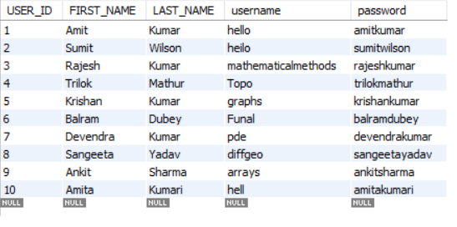

Vehicle table

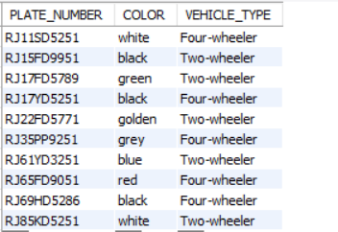

Owner table

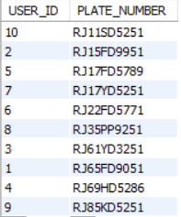

Gate_log table

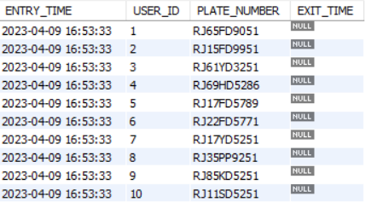

select * from user;

select * from vehicle;

select * from owner;

select * from gate_log;

use gate_management;

## 

## 3. Functionalities

-- user authentication

DELIMITER $$

CREATE DEFINER=`root`@`localhost` FUNCTION

`password_auth`(username varchar(25),password varchar(25)) RETURNS varchar(50)

DETERMINISTIC

begin

declare result varchar(30);

IF EXISTS (SELECT * FROM user WHERE password=password AND username=username)

THEN SET result = 'User Authenticated';

ELSEIF NOT EXISTS (SELECT * FROM user WHERE password=password AND username=username)

THEN SET result = 'User not Authenticated';

END IF;

return result;

end$$

DELIMITER ;

-- calling user authentication function

select gate_management.password_auth('hello', 'amitkumar');

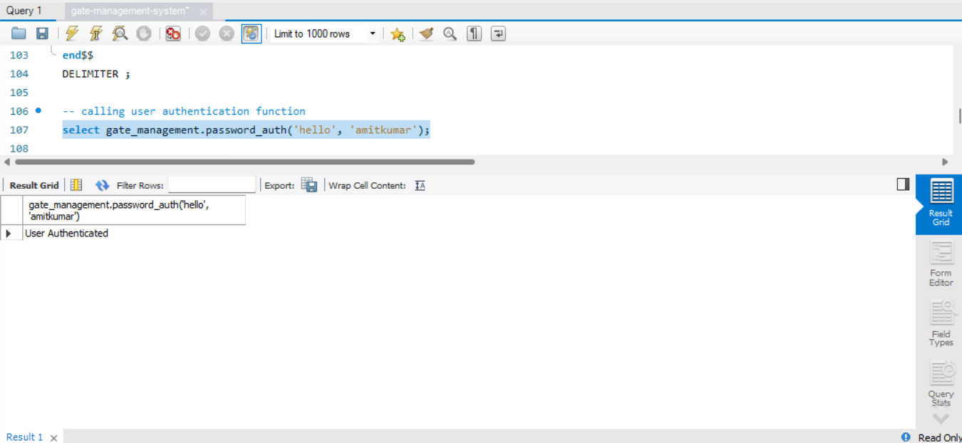

-- to reset password

update user set password="1234" where username = "hello" AND FIRST_NAME="Amit";

select gate_management.password_auth('hello', '1234');

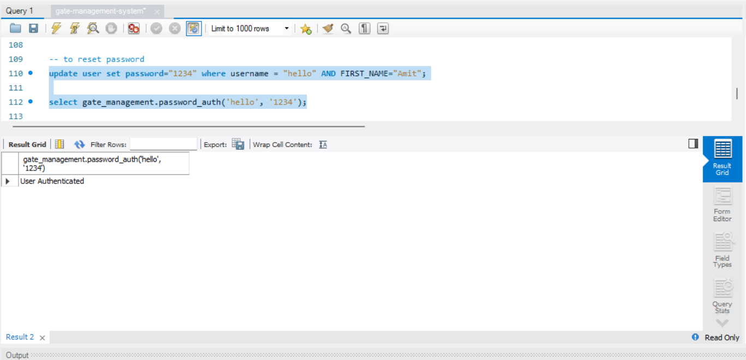

-- to register vehicle by user

start TRANSACTION;

insert into vehicle (PLATE_NUMBER,COLOR,VEHICLE_TYPE) VALUES ("RJ15ZX2233","white","Two-wheeler");

insert into owner (USER_ID,PLATE_NUMBER) VALUES (5,"RJ15ZX2233");

commit ;

select * from vehicle NATURAL JOIN owner;

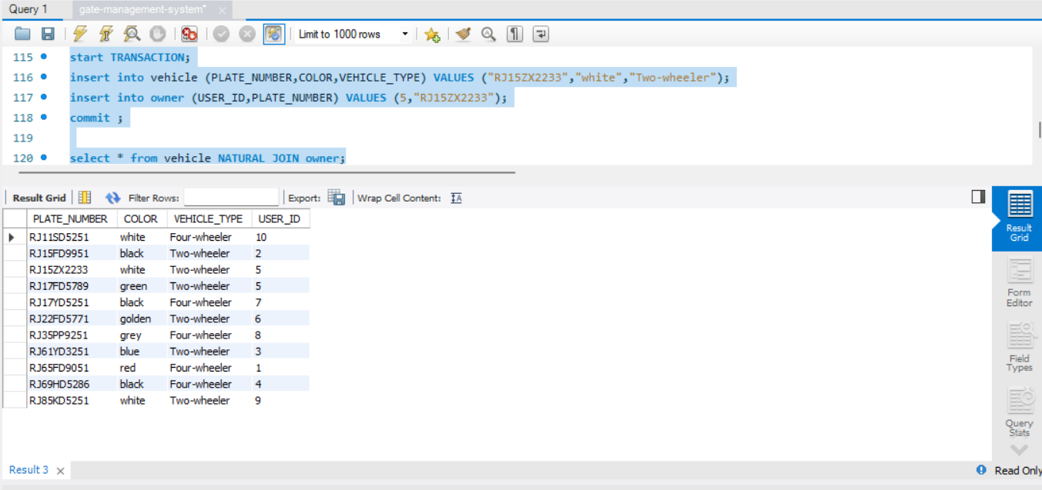

-- to search for vehicle record based on user FIRST NAME

select PLATE_NUMBER,COLOR,VEHICLE_TYPE from user NATURAL JOIN owner NATURAL JOIN vehicle where FIRST_NAME="Amit";

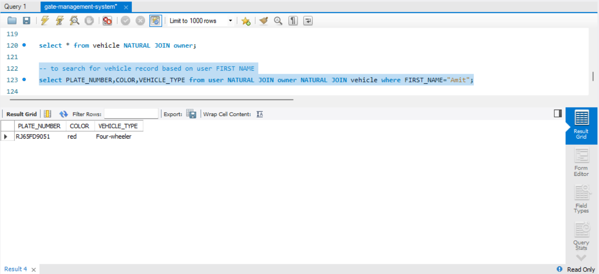

-- gate authority to record entry exit time

update gate_log set EXIT_TIME =current_timestamp() where USER_ID=1 AND PLATE_NUMBER="RJ65FD9051";

select * from gate_log;

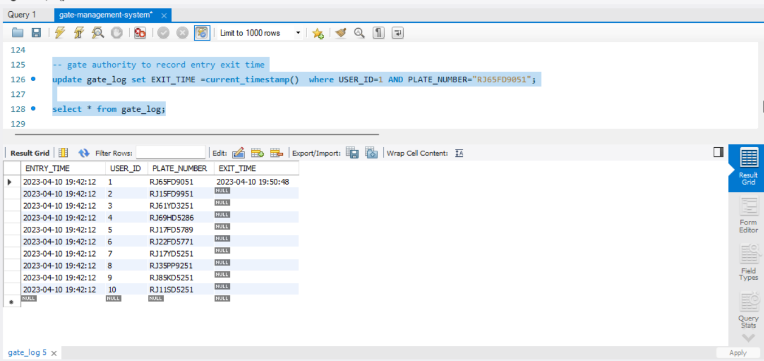

-- entry/exit time received by user

select PLATE_NUMBER,ENTRY_TIME,EXIT_TIME from gate_log where USER_ID=1;

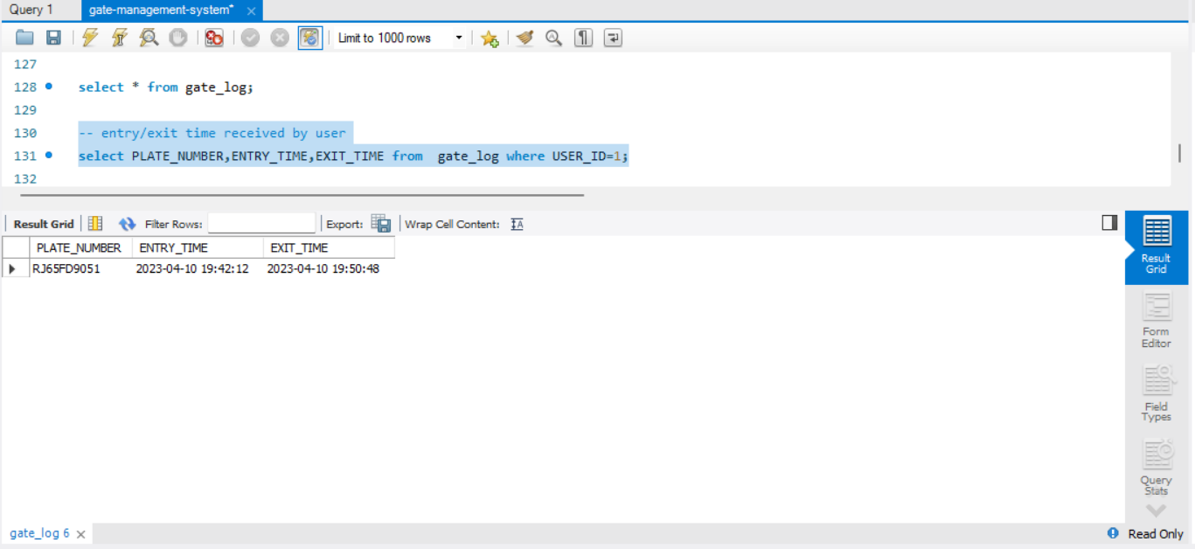

-- vehicle types

select VEHICLE_TYPE,count(*) from vehicle group by VEHICLE_TYPE;

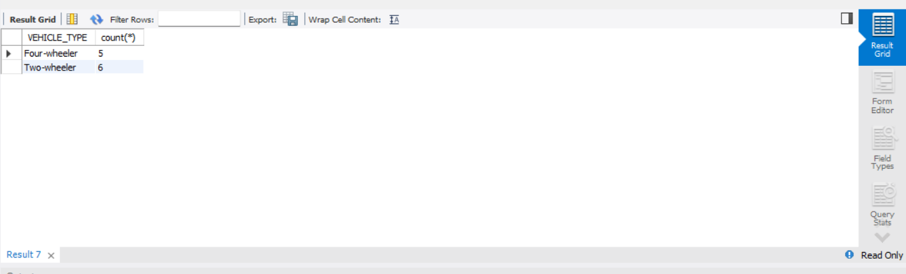

-- peak hour wise

select extract(hour from ENTRY_TIME) as hr,count(*) from gate_log group by extract(hour from ENTRY_TIME)order by 1;

